Explore the dataset and determine what is the target variable. (1) 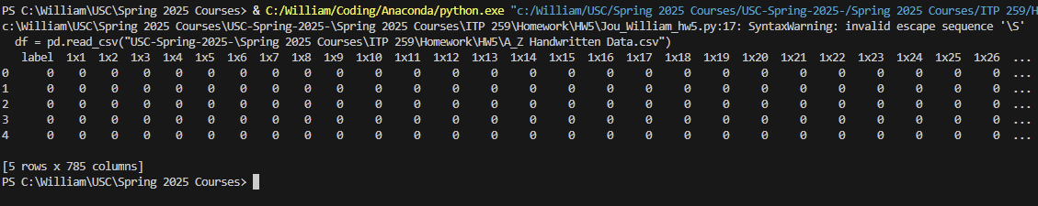

Print the shape of feature set and target variable. (1)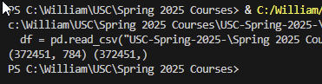

Show a histogram (count) of the letters. (1)

Display 64 random letters from the dataset. Display their labels as shown below. Hint: Plot a pyplot figure. Use plt.subplot to make the 64 subplots. Use a for loop to iterate through each one. (2) A screenshot of a computer screen

*Fit* to train the model. (1)

Plot the loss curve. (1)

Display the *accuracy* of your model. (1)

Plot the *confusion matrix* along with the letters. (1)

Now, display the *predicted* letter of the first row in the test dataset. Also display the *actual* letter. Show both *actual* and *predicted* letters (as title) on the image of the letter. (3)

Finally, display the actual and predicted letter of a *misclassified* letter. (3)

